**Department of Electronics and Telecommunication Engineering**

**PART-A (About 2-3 Pages)**

**Format for Micro-Project Proposal**

**For 1st to 4th Semester**

**Title of Micro Project:**

Flood control features of the Rio Grande Canalization Project

**1.0 Brief Introduction: (Importance of the Project, in about 4 to 5 sentences)**

The Proposed Action would increase the flood containment capacity of the Rio Grande Canalization Project Levee System by raising the elevation of a number of levee segments for improved flood protection. Fill material, obtained from commercial sources would be added to the existing levee to meet the 3 foot freeboard criterion.

**2.0 Aim of the Micro Project (in about 4 to 5 sentences)**

Raise approximately 52 miles of levees and construct new flood control structures along the Rio Grande Canalization Project to meet current requirements for flood control.In some instances, adjustments in levee slope would be made to eliminate the need for levee footprint expansion, when required by engineering considerations or for protection of resources.

**3.0 Action Plan (Sequence and time required for major activities for 8 weeks)**

|  |  |  |  |  |
| --- | --- | --- | --- | --- |
| **Sr.** | **Details of Activity** | **Planned** | **Planned** | **Name of Responsible** |
| **No.** |  | **Start Date** | **Finish Date** | **Team Members** |
| 1 | Reading the report | 25/6/20 | 25/6/20 | Sania Bandekar |
| 2 | Scrutinising the report | 27/6/20 | 29/6/20 | Sania Bandekar |
|  |  |  |  |  |
| 3 | Analyzing impact on flora and fauna | 30/6/20 | 30/6/20 | Sania Bandekar |
| 4 | Proposing the Levee system | 27/7/20 | 30/7/20 | Sania Bandekar |
| 5 | Formatting the Report | 27/8/20 | 30/9/20 | Sania Bandekar |
|  |  |  |  |  |

**4.0 Resources Required (Such as raw material, some machining facility, software etc.)**

|  |  |  |  |  |
| --- | --- | --- | --- | --- |
| **Sr.** | **Name of Resource/Material** | **Specifications** | **Qty** | **Remarks** |
| **No.** |  |  |  |  |
| 1 | BISON 2007 | Species Reports. [[http://www.bison-m.org/ - accessed September 2007](http://www.bison-m.org/%20-%20accessed%20September%202007)] | N/A | N/A |
| 2 | NMED 2007 | Air Quality Bureau. Doña Ana County NM [[http://www.nmenv.state.nm.us/aqb/control_strat/sip/dona_ana_county_new_mexico.html – accessed September 2007](http://www.nmenv.state.nm.us/aqb/control_strat/sip/dona_ana_county_new_mexico.html%20%E2%80%93%20accessed%20September%202007)] | N/A |  |
| 3 | TCEQ2007 | Point Source Emissions Inventory by County, Texas Commission on Environmental Quality. [[http://www.tceq.state.tx.us/nav/data/aq_data.html – accessed March 2007](http://www.tceq.state.tx.us/nav/data/aq_data.html%20%E2%80%93%20accessed%20March%202007)] |  |  |
|  |  |  | N/A | N/A |
| 4 | TPWD 2007 | Threatened and Endangered Species Annotated County | N/A | N/A |
| 5 | USEPA 2007 | Emissions by Category Report - Criteria Air Pollutants El Paso County Texas – 2007. [[http://www.epa.gov/air/data/index.html, accessed September 2007](http://www.epa.gov/air/data/index.html,%20accessed%20September%202007)] | N/A | N/A |

Annexure-IA

**Department of Electronics and Telecommunication Engineering**

**PART-B (Outcomes after Execution and Format for Micro-Project Report, About 6-10 Pages) For 1st to 4th Semester**

**Title of Micro Project:** Flood control features of the Rio Grande Canalization Project

**1.0 Brief Description: (Importance of the project, in about 100 to 200 words)**

The Proposed Action would increase the flood containment capacity of the Rio Grande Canalization Project Levee System by raising the elevation of a number of levee segments for improved flood protection. Fill material, obtained from commercial sources would be added to the existing levee to meet the 3 foot freeboard criterion.

**2.0 Aim of Micro Project: (in about 100 to 200 words)**

Raise approximately 52 miles of levees and construct new flood control structures along the Rio Grande Canalization Project to meet current requirements for flood control.In some instances, adjustments in levee slope would be made to eliminate the need for levee footprint expansion, when required by engineering considerations or for protection of resources.

**3.0 Course Outcomes Integrated (Add to the earlier list if more CO’s are addressed)**

* Develop public awareness about the environment
* Select alternative energy resources for engineering practice
* Conserve the ecosystem and Biodiversity
* Apply techniques to reduce environmental pollution
* Manage social issues and Environmental Ethics as lifelong learning

**4.0 Actual Procedure followed**

(Write stepwise the work done, including team member did what work and how the data was analyzed, if any)

**5.0 Actual Resources Used: (Mention the actual resources used)**

|  |  |  |  |  |
| --- | --- | --- | --- | --- |
| **Sr.** | **Name of Resource/Material** | **Specifications** | **Qty** | **Remarks** |
| **No.** |  |  |  |  |
| 1 | BISON 2007 | Species Reports. [[http://www.bison-m.org/ - accessed September 2007](http://www.bison-m.org/%20-%20accessed%20September%202007)] | N/A | N/A |
| 2 | NMED 2007 | Air Quality Bureau. Doña Ana County NM [[http://www.nmenv.state.nm.us/aqb/control_strat/sip/dona_ana_county_new_mexico.html – accessed September 2007](http://www.nmenv.state.nm.us/aqb/control_strat/sip/dona_ana_county_new_mexico.html%20%E2%80%93%20accessed%20September%202007)] | N/A |  |
| 3 | TCEQ2007 | Point Source Emissions Inventory by County, Texas Commission on Environmental Quality. [[http://www.tceq.state.tx.us/nav/data/aq_data.html – accessed March 2007](http://www.tceq.state.tx.us/nav/data/aq_data.html%20%E2%80%93%20accessed%20March%202007)] |  |  |
|  |  |  | N/A | N/A |
| 4 | TPWD 2007 | Threatened and Endangered Species Annotated County | N/A | N/A |
| 5 | USEPA 2007 | Emissions by Category Report - Criteria Air Pollutants El Paso County Texas – 2007. [[http://www.epa.gov/air/data/index.html, accessed September 2007](http://www.epa.gov/air/data/index.html,%20accessed%20September%202007)] | N/A | N/A |

**6.0 Outputs of the M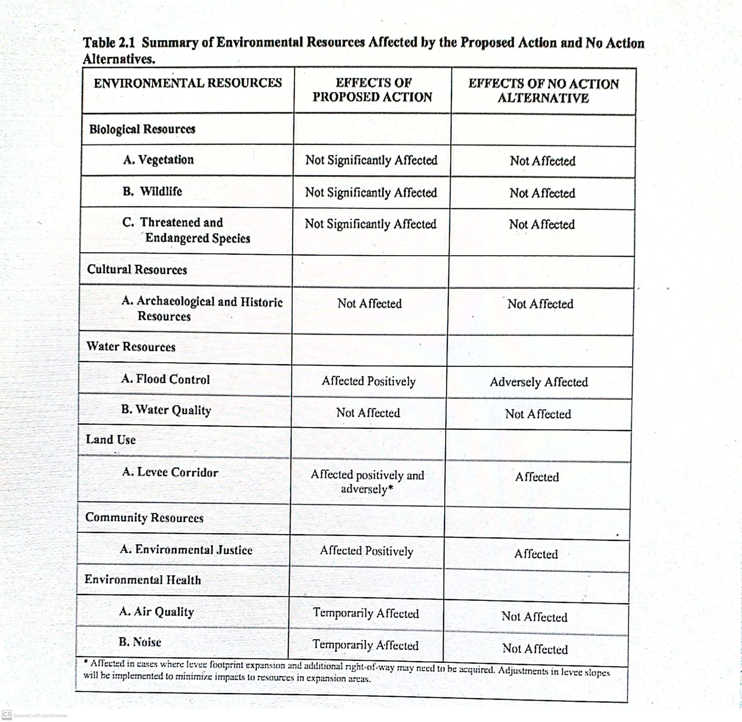icro Projects**

**7.0 Skill Developed/Learning out of this Micro Project** (In about 150 to 300 words)

* Reading the report
* Scrutinising the report
* Analyzing impact on flora and fauna
* Proposing the Levee system
* Formatting the Report

Annexure-IIA

**Department of Electronics and Telecommunication Engineering**

**Name of Student: Sania Bandekar** **Enrollment No: 17201B0022**

**Name of Programme:** **Semester: 5th**

**Course Title:** **Code:**

**Title of the Micro Project:** Flood control features of the Rio Grande Canalization Project

**Course Outcomes Achieved:**

**Micro Project Evaluation Sheet**

|  |  |  |  |  |
| --- | --- | --- | --- | --- |
| **Process Assessment** | | **Product Assessment** | | **Total** |
| **Part-A** | **Project** | **Part-B** | **Individual** | **Marks 10** |
| **Project Proposal** | **Methodology** | **Project Report/** | **Presentation/** |  |
| **(Mark-2)** | **(Mark-2)** | **Working Model** | **Viva** |  |
|  |  | **(Marks-2)** | **(Marks-4)** |  |
|  |  |  |  |  |

**Note: Every course teacher is expected to assign marks for group evolution in first 3 columns and individual in 4th columns for each group of students as per rubrics.**

**Comments/Suggestions about team work/leadership/inter-personal communication (if any)**

**----------------------------------------------------------------------------------------------------------------------------**

**----------------------------------------------------------------------------------------------------------------------------**

**Any other Comments:**

**----------------------------------------------------------------------------------------------------------------------------**

**----------------------------------------------------------------------------------------------------------------------------**

**Name and Designation of Faculty Members**

**Signature:**